|  |  |  |  |
| --- | --- | --- | --- |
| C:\Documents and Settings\Administrator\My Documents\Dropbox\Documents\MyDocuments\grafik\logo politeknik.png  **TUANKU SYED SIRAJUDDIN** | **DEPARTMENT OF INFORMATION TECHNOLOGY AND COMMUNICATION** | **SESSION** | 1:2021/2022 |
| **COURSE** | DFT40043  WEB DESIGN TECHNOLOGIES |
| **ASSESSMENT METHOD** | LABORATORY TASK 2 |
| **TOPIC** | 3.0 CASCADING STYLE SHEETS | | |

|  |  |  |
| --- | --- | --- |
| Name : NIK DANIA ARIESYA BINTI MOHD RASHIDI | | **MARKS** |
| Reg. No : 18DDT19F1127 | Class : DDT5D | /20 |

|  |  |  |  |  |
| --- | --- | --- | --- | --- |
| **Criteria** | Login Page | | Create New Account | |
| HTML Tags | CSS | HTML Tags | CSS |
| **Marks** |  |  |  |  |

**ANSWER**

LOGIN PAGE

SCREENSHOT

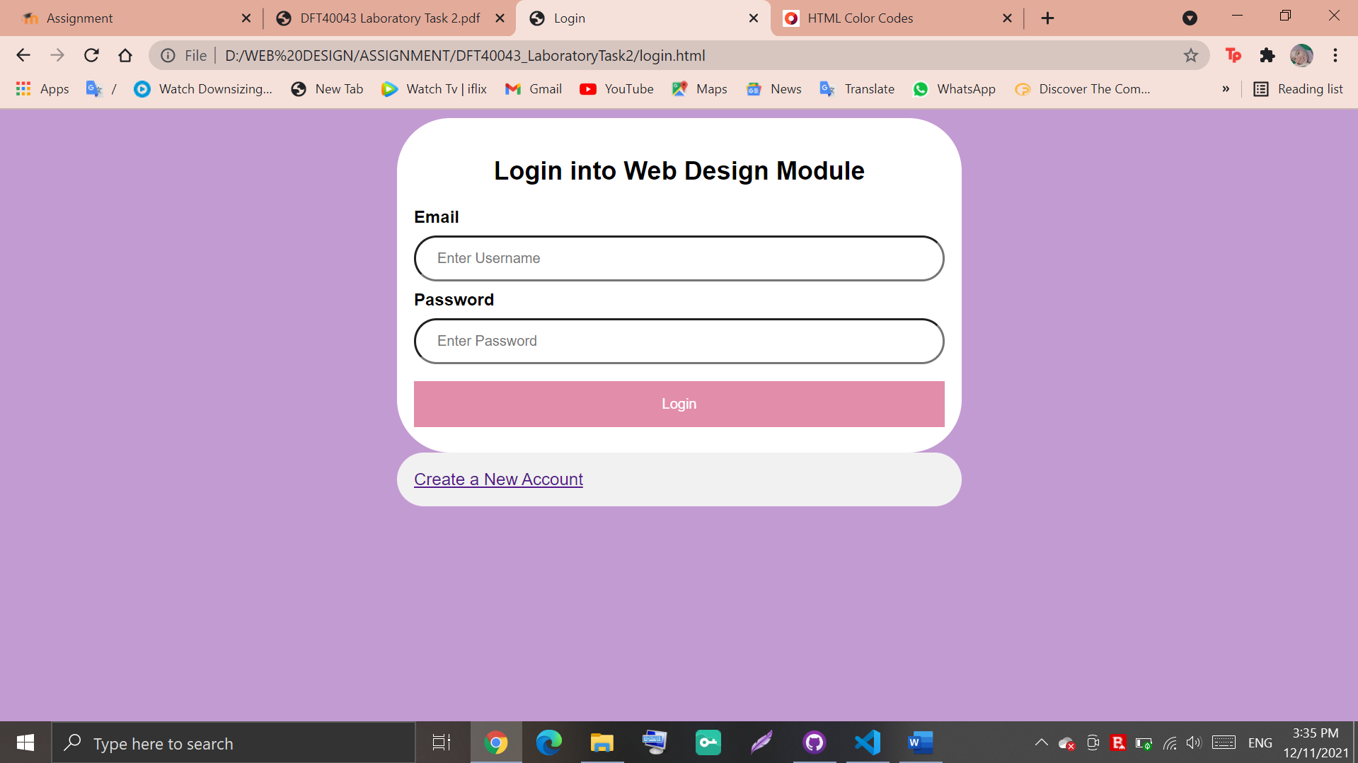

CODING (HTML)

<!DOCTYPE html>

<html lang="en">

<head>

<meta charset="UTF-8">

<meta http-equiv="X-UA-Compatible" content="IE=edge">

<meta name="viewport" content="width=device-width, initial-scale=1.0">

<title>Login</title>

<link rel="stylesheet" href="design.css">

</head>

<body>

<form action="/action_page.php" method="post">

<div class="container">

<center>

<h2>Login into Web Design Module</h2>

</center>

<label for="uname"><b>Email</b></label>

<input type="text" placeholder="Enter Username" name="uname" required>

<label for="psw"><b>Password</b></label>

<input type="password" placeholder="Enter Password" name="psw" required>

<button type="submit">Login</button>

</div>

<div class="container" style="background-color:#f1f1f1">

<a href="registeration.html" target="_blank">Create a New Account</a>

</div>

</form>

</body>

</html>

CODING (CSS)

body {font-family: Arial, Helvetica, sans-serif;}

input[type=text], input[type=password] {

width: 100%;

padding: 12px 20px;

margin: 8px 0;

display: inline-block;

border-radius: 50px;;

box-sizing: border-box;

}

button {

background-color: palevioletred;color: white;

padding: 14px 20px;

margin: 8px 0;

border: none;

cursor: pointer;

width: 100%;

}

button:hover {

opacity: 0.8;

}

.cancelbtn {

width: auto;

padding: 10px 18px;

background-color: #f44336;

}

.imgcontainer {

text-align: center;

margin: 24px 0 12px 0;

}

img.avatar {

width: 40%;

border-radius: 50%;

}

.container {

padding: 16px;

max-width: 500px;

margin: auto;

background: white;

border-radius: 50px;

}

span.psw {

float: right;

padding-top: 16px;

}

/* Change styles for span and cancel button on extra small screens */

@media screen and (max-width: 300px) {

span.psw {

display: block;

float: none;

}

.cancelbtn {

width: 100%;

}

}

body {

background-color: #C39BD3;

}

CREATE NEW ACCOUNT

SCREENSHOT

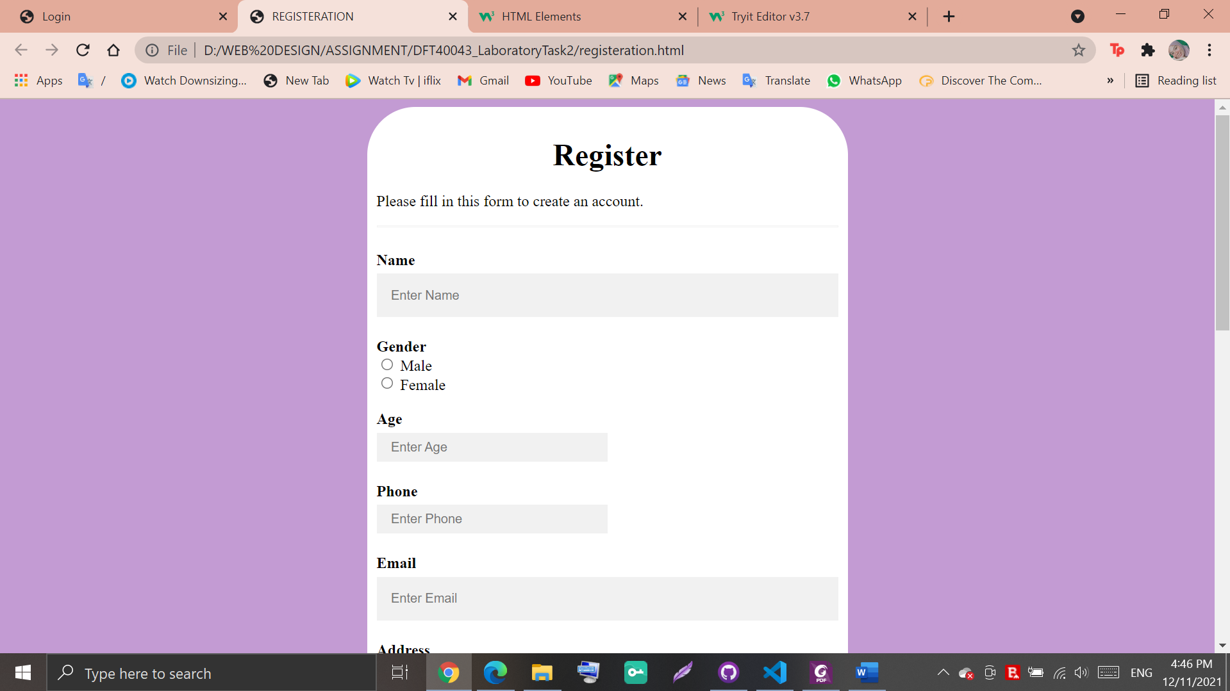

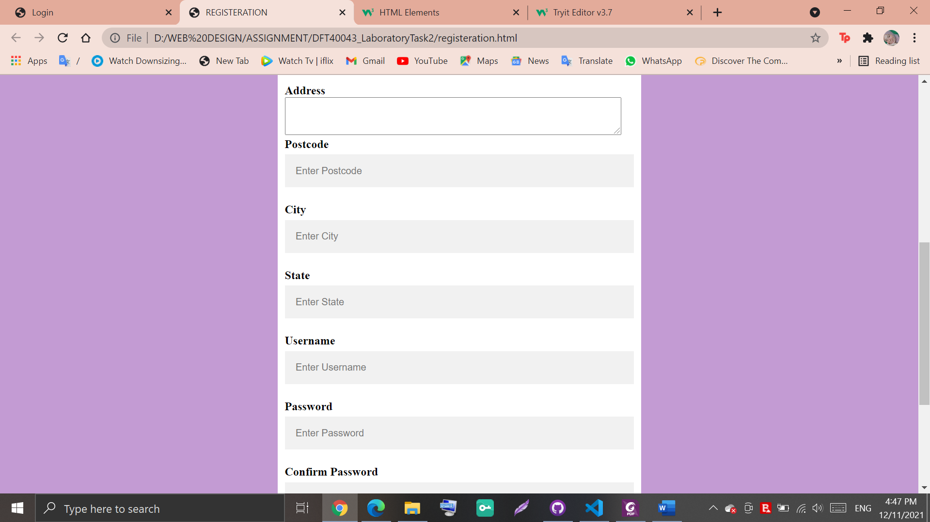

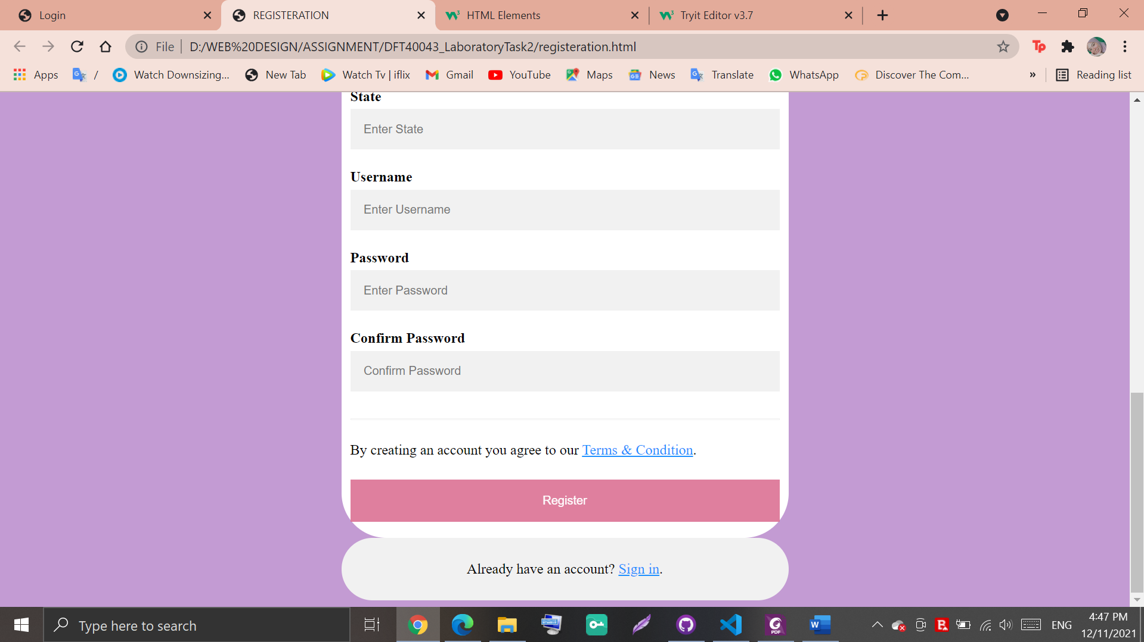

CODING (HTML)

<!DOCTYPE html>

<html lang="en">

<head>

<meta charset="UTF-8">

<meta http-equiv="X-UA-Compatible" content="IE=edge">

<meta name="viewport" content="width=device-width, initial-scale=1.0">

<link rel="stylesheet" href="style.css">

<title>REGISTERATION</title>

</head>

<body>

<form action="action_page.php">

<div class="container">

<center>

<h1>Register</h1>

</center>

<p>Please fill in this form to create an account.</p>

<hr>

<label for="name"><b>Name</b></label>

<input type="text" placeholder="Enter Name" name="name" id="name" required>

<label for="Gender"><b>Gender</b></label><br>

<input type="radio" id="male" name="gender" value="male">

<label for="male">Male</label><br>

<input type="radio" id="female" name="gender" value="female">

<label for="female">Female</label>

<br>

<br>

<label for="age"><b>Age</b></label>

<br>

<input type="number" id="age" placeholder="Enter Age" name="age" equired>

<br>

<label for="phone"><b>Phone</b></label>

<br>

<input type="number" placeholder="Enter Phone" name="phone" id="phone" required>

<br>

<label for="email"><b>Email</b></label>

<input type="text" placeholder="Enter Email" name="email" id="email" required>

<label for="address"><b>Address</b></label>

<textarea id="address" name="address" rows="3" cols="60"></textarea>

<br>

<label for="postcode"><b>Postcode</b></label>

<input type="text" placeholder="Enter Postcode" name="postcode" id="postcode" required>

<label for="city"><b>City</b></label>

<input type="text" placeholder="Enter City" name="city" id="city" required>

<label for="state"><b>State</b></label>

<input type="text" placeholder="Enter State" name="state" id="state" required>

<label for="username"><b>Username</b></label>

<input type="text" placeholder="Enter Username" name="username" id="username" required>

<label for="psw"><b>Password</b></label>

<input type="password" placeholder="Enter Password" name="psw" id="psw" required>

<label for="psw-confirm"><b>Confirm Password</b></label>

<input type="password" placeholder="Confirm Password" name="psw-confirm" id="psw-confirm" required>

<hr>

<p>By creating an account you agree to our <a href="TermsAndCond.html">Terms & Condition</a>.</p>

<button type="submit" class="registerbtn">Register</button>

</div>

<div class="container signin">

<p>Already have an account? <a href="#">Sign in</a>.</p>

</div>

</form>

</body>

</html>

CODING (CSS)

* {

box-sizing: border-box

}

/* Add padding to containers */

.container {

max-width: 500px;

margin: auto;

background: white;

padding: 10px;

border-radius: 50px;

}

/* Full-width input fields */

input[type=text],

input[type=password]

{

width: 100%;

padding: 15px;

margin: 5px 0 22px 0;

display: inline-block;

border: none;

background: #f1f1f1;

}

input[type=number]

{

width: 50%;

height: 20px;

padding: 15px;

margin: 5px 0 22px 0;

display: inline-block;

border: none;

background: #f1f1f1;

}

input[type=text]:focus,

input[type=password]:focus,

input[type=number]:focus

{

background-color: #ddd;

outline: none;

}

/* Overwrite default styles of hr */

hr {

border: 1px solid #f1f1f1;

margin-bottom: 25px;

}

/* Set a style for the submit/register button */

.registerbtn {

background-color:palevioletred;

color: white;

padding: 16px 20px;

margin: 8px 0;

border: none;

cursor: pointer;

width: 100%;

opacity: 0.9;

}

.registerbtn:hover {

opacity: 1;

}

/* Add a blue text color to links */

a {

color: dodgerblue;

}

/* Set a grey background color and center the text of the "sign in" section */

.signin {

background-color: #f1f1f1;

text-align: center;

}

body {

background-color: #C39BD3;

}